Pat, I am super sorry that I missed the step verifying the email… so my request wasn’t submitted properly.. I requested again with proper verifying.. I will work on it as soon as I my request is accepted. Sorry about that.

Amazon SageMaker

Table of Contents

SageMaker Studio Lab Introduction 1

Getting Started with SageMaker Studio Lab 1

AutoGluon Introduction 2

Enabling the Virtual Environment 3

AutoGluon for Classification Model Creating and Evaluation 4

Loading AutoGluon Models from a Binary File 8

AutoGluon for Linear Regression 9

Image Classification 11

## SageMaker Studio Lab Introduction

Amazon’s Sagemaker platform enables machine learning in the cloud through AWS. SageMaker Studio Lab by AWS is a free (but similar) version of the paid SageMaker Studio by AWS.

Some exciting features of SageMaker Studio Lab make it ideal for students:

* A credit card is not required for SageMaker Studio Lab.
* You can run your notebooks on a regular CPU for 11 hours straight.
* You can also obtain GPU access through to 4 hours per session.
* Your files will persist in your account folder so you can both upload your own data or save your models and then download them later for use on your local machine.

## Getting Started with SageMaker Studio Lab

To create a Sagemaker account go to <https://studiolab.sagemaker.aws/>

Once you have created an account and have logged in, click start runtime. For really heavy jobs that require GPU, select GPU before starting the runtime. Note though, if you use GPU, you will only have access to a 4-hour session. You may use GPU in future sessions but you will need to wait approximately one day before being able to use this feature again. Also note that the GPU option is not always available depending on the amount of current GPU users. I have also found that the CPU is not available at certain times of the day.



Once SageMaker Studio Lab is running click **Open Project**.

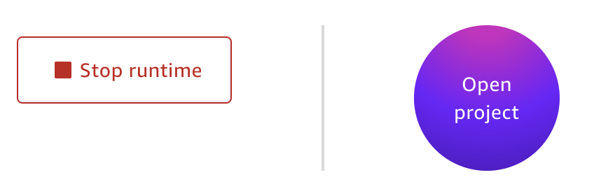

Example : Simple Logistic Regression

This example demonstrates how to perform simple logistic regression with SageMaker Studio Lab.



Placing this code in the cell will run the project.

|  |
| --- |
| from sklearn.linear_model import LogisticRegression  from sklearn import datasets  from sklearn.model_selection import train_test_split  import pandas as pd  # Load data from sklearn library.  df = pd.read_csv("iris_v2.csv")  X = df.copy()  del X['iris_type']  y = df['iris_type']  # Split data.  X_train,X_test,y_train,y_test = train_test_split(  X, y, test_size=0.25)  # Create one-vs-rest logistic regression object  clf = LogisticRegression(  random_state=0,  multi_class='multinomial', solver='newton-cg')  # Train model  model = clf.fit(X_train, y_train)  # Predict class  y_pred = model.predict(X_test)  print(y_pred)  # Show confusion matrix and accuracy scores.  from sklearn import metrics  cm = pd.crosstab(y_test, y_pred, rownames=['Actual'], colnames=['Predicted'])  print('\nAccuracy: ',metrics.accuracy_score(y_test, y_pred))  print("\nConfusion Matrix")  print(cm) |

## AutoGluon Introduction

AutoGluon is an open-source automatic machine learning framework that is developed by Amazon. AutoGluon enables easy-to-use and easy-to-extend AutoML with a focus on automated stack ensembling, deep learning, and real-world applications spanning image, text, and tabular data. AutoGluon enables you to:

* Quickly prototype deep learning and classical ML solutions for your raw data with a few lines of code.
* Automatically use state-of-the-art techniques (where appropriate) without expert knowledge.
* Leverage automatic hyperparameter tuning, model selection/ensembling, architecture search, and data processing.
* Customize AutoGluon for your use-case.

For more information about AutoGluon see <https://www.youtube.com/watch?v=UYW_gfZLFXE>

For current documentation see <https://auto.gluon.ai/>

Example : Setting Up AutoGluon

This example walks through the steps of setting up AutoGluon and using it for basic classification. This example is based the quick start tutorial at

<https://github.com/aws/studio-lab-examples/blob/main/custom-environments/AutoGluon/env_validation.ipynb>

### Enabling the Virtual Environment

To begin, run the following Notebook cell to generate a YAML file for creating the Anaconda virtual environment.

|  |
| --- |
| %%writefile autogluon_cpu.yml  *# run in terminal: conda env create --file autogluon_cpu.yml*  *# note: This command creates an environment that is larger than 4GB.*  name: autogluon_cpu  dependencies:  - python=3.7  - conda  - pip  - ipykernel  - nodejs  - pip:  - ipywidgets  - setuptools  - wheel  - mxnet<2.0.0  - autogluon  - jupyter_bokeh |

After running the script above, the autogluon_cpu.yml file will be generated in home directory for your account:

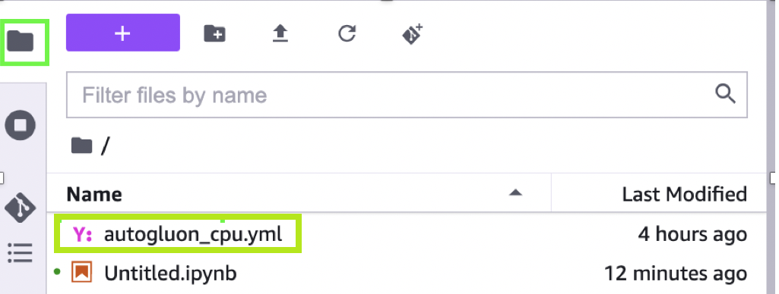

Next, to create a virtual environment for Anaconda with AutoGluon in SageMaker Studio Lab, run the following command in the system terminal. You can open the Terminal from **File | New | Terminal**.



Once the terminal is open enter the following command:

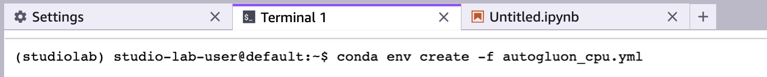

|  |
| --- |
| conda env create -f autogluon_cpu.yml |

**Note:**

To activate this AutoGluon virtual environment, use:

$ conda activate autogluon_cpu

To deactivate an active environment, use:

$ conda deactivate

To delete the environment run:

conda remove --name autogluon_cpu --all

If the installation is successful, you should be able to select autogluon_cpu:Python in the popup that appears when you click the kernel name in the upper right corner of the screen.

Switch to the autogluon_cpu:Python kernel. You will now be able to use AutoGluon.



## AutoGluon for Classification Model Creating and Evaluation

Example : AutoGluon for Classification

This example shows the steps to implement AutoGluon for automating the development of a classification algorithm. To begin, import the packages:

|  |
| --- |
| from autogluon.tabular import TabularDataset, TabularPredictor  from IPython.display import HTML |

Then, load the data from s3 bucket and start making predictions. AutoGluon infers whether a classification or linear regression is being made from the data. For classification problems, the eval_metric property defaults to accuracy. Note that the evaluation metric in this example is set to eval_metric='recall'. If you need you could use these options:

‘accuracy’, ‘balanced_accuracy’, ‘f1’, ‘f1_macro’, ‘f1_micro’, ‘f1_weighted’, ‘roc_auc’, ‘roc_auc_ovo_macro’, ‘average_precision’, ‘precision’, ‘precision_macro’, ‘precision_micro’, ‘precision_weighted’, ‘recall’, ‘recall_macro’, ‘recall_micro’, ‘recall_weighted’, ‘log_loss’, ‘pac_score’

Here is the code that loads the data from Amazon S3 buckets and fits the model.

|  |
| --- |
| train_data = TabularDataset('https://autogluon.s3.amazonaws.com/datasets/Inc/train.csv')  test_data = TabularDataset('https://autogluon.s3.amazonaws.com/datasets/Inc/test.csv')  predictor = TabularPredictor(label='class',eval_metric='recall', path='ag-default').fit(train_data, time_limit=120) # Fit models for 120s |

Running the cell triggers processes for preparing the data, imputing, searching for features, building and evaluating different models. The models are saved to a folder called 'ag-default' when the code above has finished executing.

For this example, AutoGluon identifies the best model: "WeightedEnsemble_L2"



To load the best model binary you can then use the following code:

predictor = TabularPredictor.load("ag-default/")

A model summary can be displayed to show statistics for each of the models that are built.

|  |
| --- |
| leaderboard = predictor.leaderboard(test_data)  print(leaderboard.T) |

The output from running the code above shows statistics for each model that was generated by AutoGluon. The best performing model (using recall) is displayed first. Then the remaining 10 models that were generated in this example are displayed. Here are the top three models that were displayed:

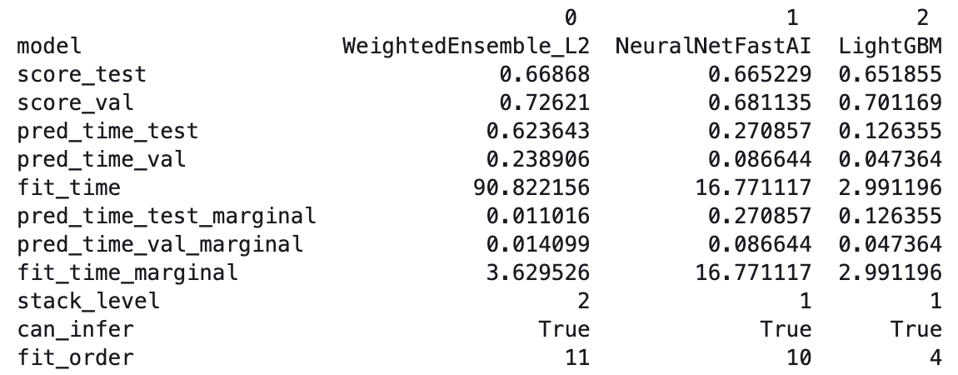

A visual summary can also be generated with the following code:

|  |
| --- |
| results = predictor.fit_summary()  HTML(filename**=**'ag-default/SummaryOfModels.html') |

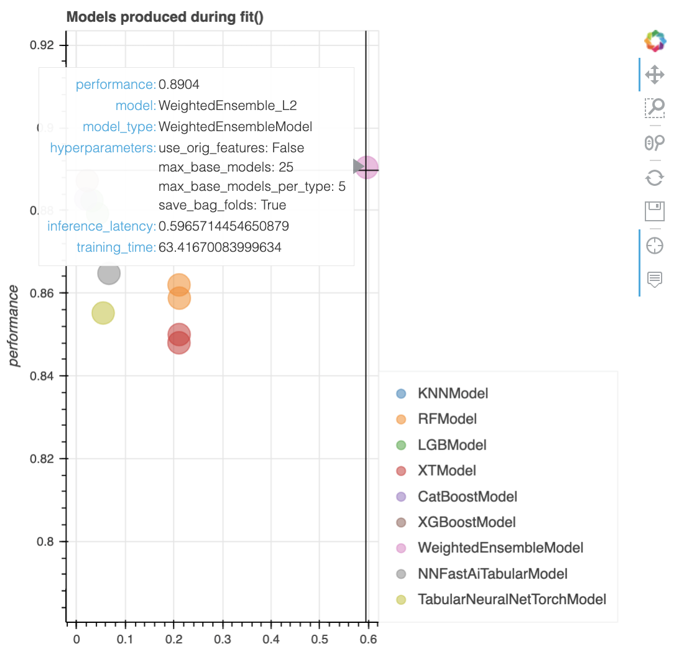

To get information about the features run the following code:

|  |
| --- |
| print(predictor.info()) |

This snippet of output from the *predictor.info()* function for the WeightedEnsemble_L2 model which, in this case, is built using 7 of the models that were fit during this process:

|  |
| --- |
| WeightedEnsemble_L2': {'name': 'WeightedEnsemble_L2',  'model_type': 'WeightedEnsembleModel',  'problem_type': 'binary',  'eval_metric': 'accuracy',  'stopping_metric': 'accuracy',  'fit_time': 1.2914869785308838,  'num_classes': 2,  'quantile_levels': None,  'predict_time': 0.00421452522277832,  'val_score': 0.8904,  'hyperparameters': {'use_orig_features': False,  'max_base_models': 25,  'max_base_models_per_type': 5,  'save_bag_folds': True},  'hyperparameters_fit': {},  'hyperparameters_nondefault': ['save_bag_folds'],  'ag_args_fit': {'max_memory_usage_ratio': 1.0,  'max_time_limit_ratio': 1.0,  'max_time_limit': None,  'min_time_limit': 0,  'valid_raw_types': None,  'valid_special_types': None,  'ignored_type_group_special': None,  'ignored_type_group_raw': None,  'get_features_kwargs': None,  'get_features_kwargs_extra': None,  'predict_1_batch_size': None,  'drop_unique': False},  'num_features': 7,  'features': ['KNeighborsUnif',  'ExtraTreesGini',  'KNeighborsDist',  'NeuralNetFastAI',  'LightGBMXT',  'XGBoost',  'LightGBM'], |

The *predictor.info()* output also shows the model weights for 'WeightedEnsemble_L2' a little further down:

|  |
| --- |
| 'model_weights': {'KNeighborsUnif': 0.014705882352941176,  'KNeighborsDist': 0.058823529411764705,  'LightGBMXT': 0.47058823529411764,  'LightGBM': 0.058823529411764705,  'ExtraTreesGini': 0.014705882352941176,  'NeuralNetFastAI': 0.058823529411764705,  'XGBoost': 0.3235294117647059}}}}}} |

As well, the output shows hyperparameters and features of the standalone models that were fit during the process. Here is parameter and feature information that is displayed for KNeighborsUnif:

|  |
| --- |
| 'model_info': {'KNeighborsUnif': {'name': 'KNeighborsUnif',  'model_type': 'KNNModel',  'problem_type': 'binary',  'eval_metric': 'accuracy',  'stopping_metric': 'accuracy',  'fit_time': 0.12332820892333984,  'num_classes': 2,  'quantile_levels': None,  'predict_time': 0.11070752143859863,  'val_score': 0.7752,  'hyperparameters': {'weights': 'uniform'},  'hyperparameters_fit': {},  'hyperparameters_nondefault': ['weights'],  'ag_args_fit': {'max_memory_usage_ratio': 1.0,  'max_time_limit_ratio': 1.0,  'max_time_limit': None,  'min_time_limit': 0,  'valid_raw_types': ['int', 'float'],  'valid_special_types': None,  'ignored_type_group_special': ['bool'],  'ignored_type_group_raw': None,  'get_features_kwargs': None,  'get_features_kwargs_extra': None,  'predict_1_batch_size': None},  'num_features': 6,  'features': ['age',  'fnlwgt',  'education-num',  'capital-gain',  'capital-loss',  'hours-per-week'],  'feature_metadata': <autogluon.common.features.feature_metadata.FeatureMetadata at 0x7fb599586190>,  'memory_size': 3483355}, |

AutoGluon also automates the rating of feature importance.

|  |
| --- |
| predictor.feature_importance(data=train_data) |

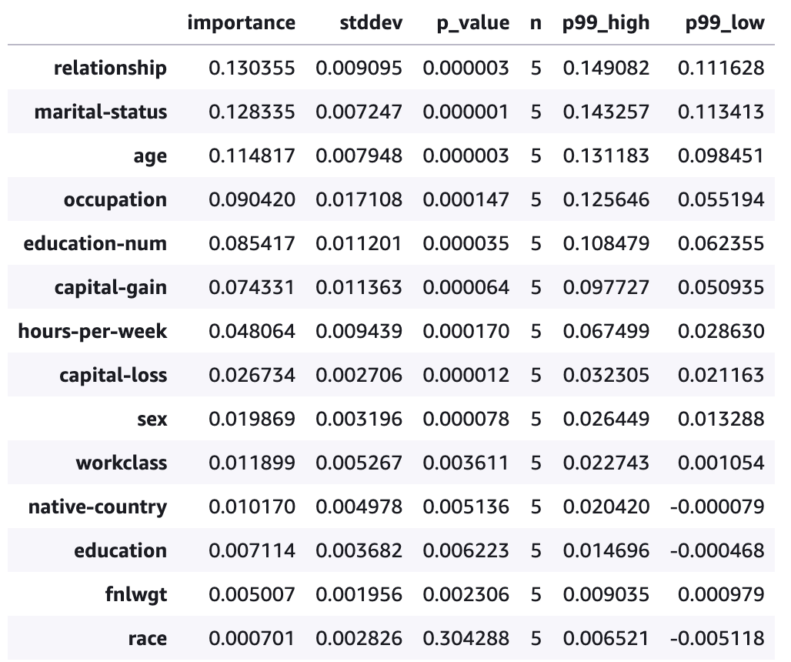

## Loading AutoGluon Models from a Binary File

Example : Loading the Models from a Binary File

Since the models are automatically saved, and since the metadata in the folder contains information on how to prepare the data, you can download the contents of the model folder and run the model locally. Or, you can keep the models in the folder in SageMaker Studio Lab and run them another day. The models and contents will persist since you have 15Gb of storage.

 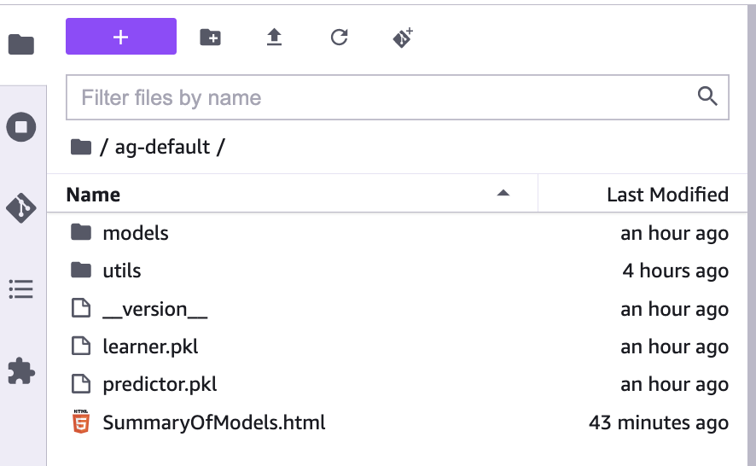

To load the best model from the binary file, use the command:

|  |
| --- |
| loadedModel = TabularPredictor.load("ag-default/")  results = loadedModel.fit_summary()  print(results) |

Exercise (2 marks)

For this exercise, upload iris_v2.csv to your SageMaker Studio Lab folder. The run the following code:

|  |
| --- |
| from autogluon.tabular import TabularDataset, TabularPredictor  from sklearn.model_selection import train_test_split  import pandas as pd  # Load data from sklearn library.  df = pd.read_csv("iris_v2.csv")  print(df)  # Split data.  train_data, test_data = train_test_split(df, test_size=0.25)  predictor = TabularPredictor(label='iris_type',eval_metric='accuracy', path='iris_models').fit(train_data, time_limit=10000) # Fit models for 120s |

Show the contents of the iris_models/models directory located here:



Show the screenshot of the directory contents here:

|  |
| --- |
|  |

Show a screenshot of feature importance output from running code that looks like the following:

predictor.feature_importance(data= train_data)

|  |
| --- |
|  |

Exercise (8 marks)

Starting with the code from Exercise 1, show the code needed to generate the following output with your best model with the binary model. You need to load the binary file and make predictions with the test data. In addition to creating and showing the confusion matrix, you will need to import the classification_report from sklearn metrics to create and display the multi-class report.

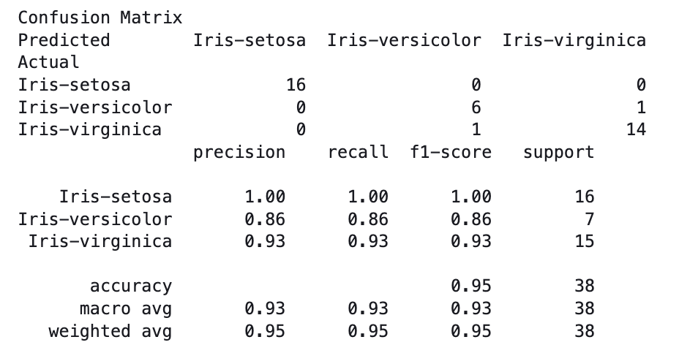

Show your code here:

|  |
| --- |
|  |

## AutoGluon for Linear Regression

Example : Linear Regression

This example shows how to implement a continuous regression with AutoGluon for predicting housing prices. The last section of output from running the code shows the best model and the RMSE. AutoGluon is able to infer that it should use RMSE from the data when building the model.

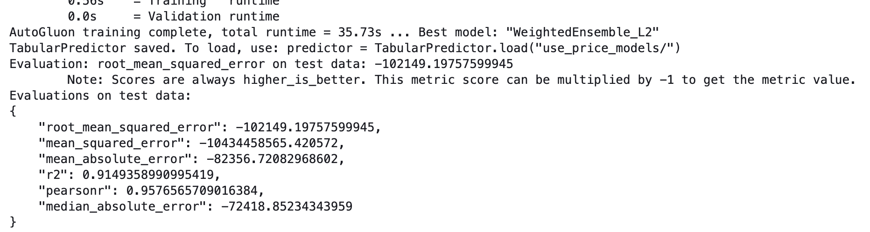

|  |
| --- |
| from autogluon.core.metrics import make_scorer  from autogluon.tabular import TabularDataset, TabularPredictor  from IPython.display import HTML  import numpy as np  import pandas as pd  # Load data from sklearn library.  df = pd.read_csv("USA_Housing.csv")  del df['Address']  print(df)  # Split data.  from sklearn.model_selection import train_test_split  train_data, test_data = train_test_split(df, test_size=0.25)  predictor = TabularPredictor(label='Price', path="use_price_models").fit(train_data, time_limit=60)  performance = predictor.evaluate(test_data) |

Exercise (1 mark)

What property allows AutoGluon to identify the target variable in the data set?

|  |
| --- |
|  |

To show the models starting with the best RMSE first, run this code:

|  |
| --- |
| leaderboard = predictor.leaderboard(test_data)  print(leaderboard.T) |

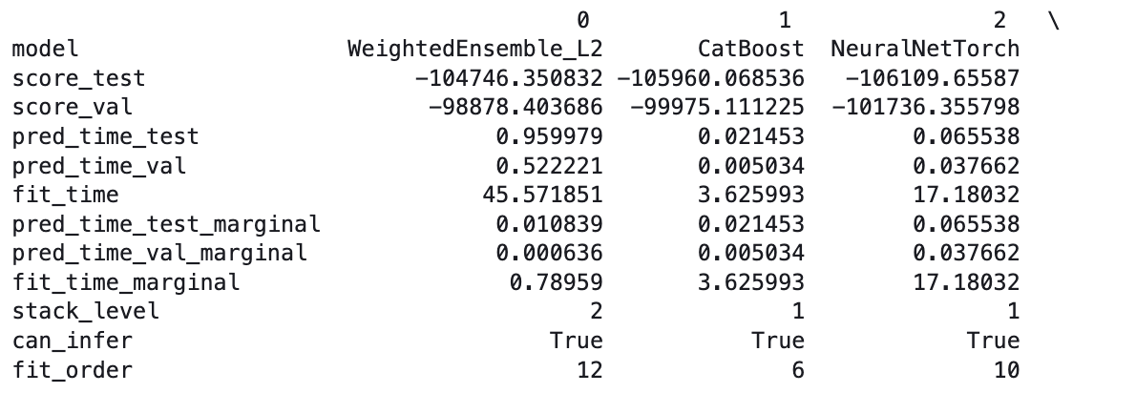

Remember, you still can use other methods to show evaluation metrics. This section of code shows how sklearn’s mean_square_error function can work with numpy’s sqrt to generate the RMSE.

|  |
| --- |
| import numpy as np  from sklearn.metrics import mean_squared_error  predictions = predictor.predict(test_data)  rmse = np.sqrt(mean_squared_error(predictions, test_data['Price']))  print(rmse) |

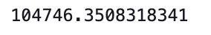

To get information about the features run the following code:

|  |
| --- |
| print(predictor.info()) |

To display feature importance ratings run this line of code:

|  |
| --- |
| predictor.feature_importance(data=train_data) |

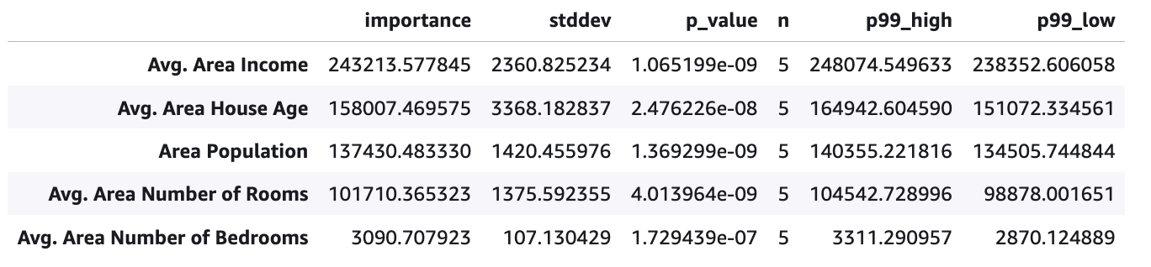

Exercise (4 marks)

Use AutoGluon to predict Petrol_Consumption with the petrol_consumption.csv file. Show a screenshot of the r2 and rmse values that appear after fitting the best model.

|  |
| --- |
|  |

Show a screenshot of the feature importances for the Petrol_Consumption model.

|  |
| --- |
|  |

## Image Classification

Example : Image Classification

This tutorial shows how to implement image classification with AutoGluon.

[https://auto.gluon.ai/stable/tutorials/multimodal/image_prediction/beginner_image_cls.html#](https://auto.gluon.ai/stable/tutorials/multimodal/image_prediction/beginner_image_cls.html)

The data contains the following possible labels: BabyPants, BabyShirt, womencasualshoes, womenchiffontop.

Note: An error occurs when running the code for the tutorial. The error occurs because ipywidgets 8 conflicts with the other libraries. cTo view your version of ipywidgets run the following code:

|  |
| --- |
| import ipywidgets  ipywidgets.__version__ |

To downgrade to a more stable version of ipywidgets, like version 7.0.0, run the following command and remember to restart the kernel when finished.

|  |
| --- |
| pip install ipywidgets==7.0.0 |

After downgrading to ipywidgets 7.0.0, get the data:

|  |
| --- |
| import warnings  warnings.filterwarnings('ignore')  import pandas as pd  from autogluon.multimodal.utils.misc import shopee_dataset  download_dir = './ag_automm_tutorial_imgcls'  train_data, test_data = shopee_dataset(download_dir)  print(train_data) |

The training and test data files contain information about the image path and a label:

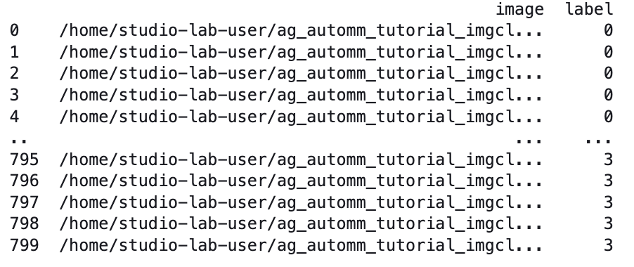

You can then view the directory by running the linux command:

|  |
| --- |
| ls /home/studio-lab-user/ag_automm_tutorial_imgcls/shopee/  ls /home/studio-lab-user/ag_automm_tutorial_imgcls/shopee/train  ls /home/studio-lab-user/ag_automm_tutorial_imgcls/shopee/train/BabyPants |

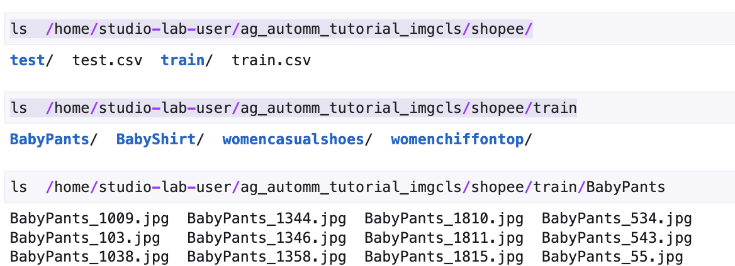

Then run the following code to fit the model. The training time has been limited to 30 seconds:

|  |
| --- |
| from autogluon.multimodal import MultiModalPredictor  import uuid  model_path = f"./tmp/{uuid.uuid4().hex}-automm_shopee"  predictor = MultiModalPredictor(label="label", path=model_path)  predictor.fit(  train_data=train_data,  time_limit=30, # seconds  ) # you can trust the default config, e.g., we use a `swin_base_patch4_window7_224` model |

To evaluate the dataset run the following code:

|  |
| --- |
| scores = predictor.evaluate(test_data, metrics=["accuracy"])  print('Top-1 test acc: %.3f' % scores["accuracy"]) |

The output shows a highly accuracy rating:



To explore the data the run the following code:

|  |
| --- |
| print(train_data.head())  print(train_data.iloc[0]['image'])  print(train_data.iloc[0]['label'])  print(train_data.iloc[500]['image'])  print(train_data.iloc[500]['label']) |

The output shows that shoes are assigned label 2.

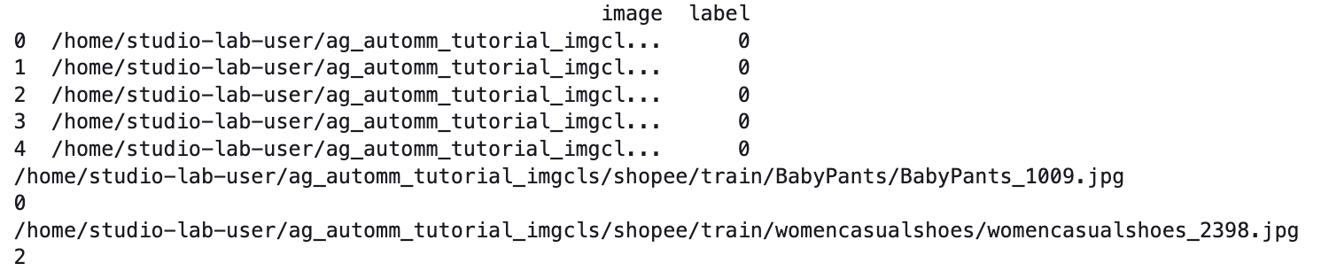

I uploaded my own shoe image and tested the model. The label of 2 was correctly identified.

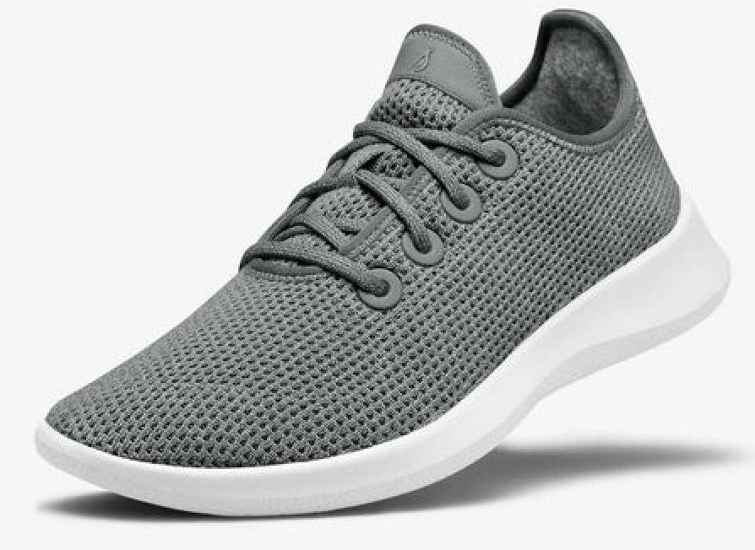



|  |
| --- |
| image_path = 'shoe2.jpg'  dfSample = pd.DataFrame(data=[{'image':image_path}])  print(dfSample)  result = predictor.predict(dfSample)  print(result) |

The prediction was correct since it predicted label 2.

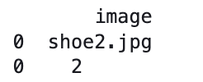

Exercise (2 marks)

Show the complete code needed to show the classification report. Here is code to get started:

|  |
| --- |
| from sklearn.metrics import classification_report  predictions = predictor.predict(test_data) |

Show your code as text here:

|  |
| --- |
|  |

Show a screenshot of the classification report for the images:

|  |
| --- |
|  |